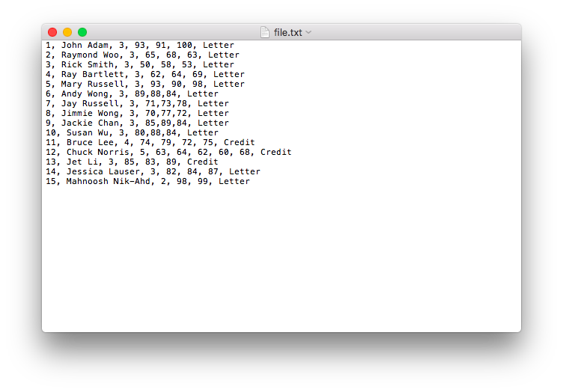

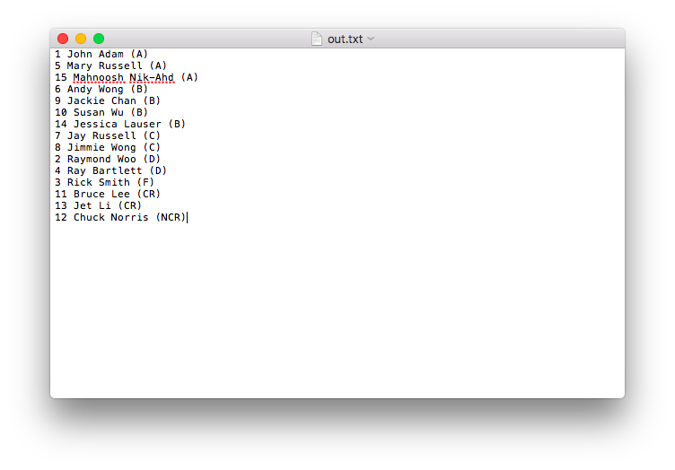

**public** **class** StudentExt **extends** Student {

**private** String gradeType;

**private** String grade_final;

**public** StudentExt(**int** id, String name, **double** [] exam, String gradeType){

**super**(id, name, exam);

**this**.gradeType = gradeType;

}

//@override

**public** String findGradeType() {

String grade = **super**.findGrade();

**if**(gradeType.equalsIgnoreCase("Credit"))

{

**if** (grade.equals("A") ||

(grade.equals("B")) ||

(grade.equals("C")) )

grade = "CR";

**else** {

grade = "NCR";

}

}

**return** grade;

}

}

**import** java.util.StringTokenizer;

**import** javax.swing.JOptionPane;

**public** **class** TestStudentExt {

**public** **static** **void** main(String[] args) {

String in, out;

String grade = **null**;

String stData;

String grade_final;

//create 10 ex student objects.

in = JOptionPane.*showInputDialog*("enter number of student "); //enter student data

**int** stCount = Integer.*parseInt*(in);

//create an array of references . just like create 10 ints. reference type has no type, they have target type.

StudentExt [] st = **new** StudentExt[stCount];

//create a student objects. in a for loop. st1, st2,..st9

String token;

**for** (**int** i =0; i < st.length ; i++){ //st.length?

in = JOptionPane.*showInputDialog*("enter one student data");

StringTokenizer stk = **new** StringTokenizer(in, ",");

token = stk.nextToken().trim(); //eliminte the spaces

**int** id = Integer.*parseInt*(token);

token = stk.nextToken().trim();

String name = token;

token = stk.nextToken().trim();

**int** examCount = Integer.*parseInt*(token);

//create an exam array. //formtt data type variable = new data_type[variable2]

**double**[] exam = **new** **double**[examCount];

//populate the array

**for** (**int** j=0; j< exam.length ; j++){

token = stk.nextToken().trim();

exam[j] = Double.*parseDouble*(token);

}

//create student object

st[i] = **new** StudentExt (id,name,exam, name);

}

//organize the students with similar grades

String outA = "", outB = "",outC = "", outD = "", outF = "", outAll = "";

**for** (**int** i =0; i<st.length; i++){

**int** id = st[i]. getId();

String name = st[i].getName();

grade = st[i].findGrade();

grade_final =st[i]. findGradeType();

stData = "" + id + " " + name + " " + ("final grade: ") + grade + "\n";

**if** (grade.equalsIgnoreCase("A")) {

outA= outA+stData;

}

**else** **if** (grade.equalsIgnoreCase("B")) {

outB= outB+stData;

}

**if** (grade.equalsIgnoreCase("C")) {

outC= outC+stData;

}

**if** (grade.equalsIgnoreCase("D")) {

outD= outD+stData;

}

**if** (grade.equalsIgnoreCase("F")) {

outF= outF+stData;

}

}

outAll = outA+outB+outC+outD+outF;

JOptionPane.*showMessageDialog*(**null**, outAll );

}

}

**public** **class** Student {

**private** **int** id;

**private** String name;

//array. data_type [] variable

**private** **double**[] exam;

//constructor. created by the source. click on the left mouse

**public** Student(**int** id, String name, **double**[] exam) {

**super**();

**this**.id = id;

**this**.name = name;

**this**.exam = exam.clone(); //clones the vlaue. creates a new array, sends a copy

}

**public** String findGrade () {

**double** sum=0;

**for** (**int** i= 0; i<exam.length; i++) {

sum = sum + exam[i];

}

**double** avg=sum/exam.length;

String grade;

**if** (avg >= 90.0) {

grade = "A";

}

**else** **if** (avg >= 80.0) {

grade = "B";

}

**else** **if** (avg >= 70.0){

grade = "C";

}

**else** **if** (avg >= 60.0){

grade = "D";

}

**else** {

grade = "F";

}

**return** grade;

}

//need to create get methods. go to any field constructor. use the source. choose geenerate getter and setters

**public** **int** getId() {

**return** id;

}

**public** String getName() {

**return** name;

}

**public** **double**[] getExam() {

**return** exam.clone();

}

}

//The sample code below input student data from file “in.txt”

//and output student data in file “out.txt”

**import** java.io.*;

**import** java.util.StringTokenizer;

**import** javax.swing.*;

**public** **class** TestStudentExt

{

**public** **static** **void** main(String[] args)

{

String in,out,outAll = **null**, line;

**int** studentCount;

//Create a BufferedReader object for inputting froma file in.txt

BufferedReader br = **new** BufferedReader(**new** FileReader("file.txt"));

//Create a PrintWriter object for outputting to a file out.txt.

PrintWriter pw = **new** PrintWriter (**new** FileWriter("out.txt"));

//input the first line of the file containing the number of students

in = br.readLine();

studentCount = Integer.parseInt(in);

//Set up a for loop to input one student data during each pass through loop.

out = "Student report:\n";

**for** (**int** i=0; i<studentCount; i++)

{

//read one line containing one student data.

in = br.readLine();

pw.write(in);

//Create a StringTokenizer object to tokenize one student data.

String delim= ",";

String token="" ;

String pattern;

StringTokenizer stk1 = **new** StringTokenizer(in, delim);

//ask to get the tokens.

**int** count = stk1.countTokens();

//create the corresponding StudentExt object

StudentExt studentObj[j] = **new** StudentExt();

}

//Set up a for loop to find grade of one student during each iteration

//Store the student data and the grade in a corresponding output String.

**for** (**int** j=0; j<studentCount; j++)

{

//Find one student grade

//Depending on student grade, accumulate its output in a corresponding String.

}

//Catenate all student output in a single String (say outAll)

//Output outAll String using using PrintWriter object.

//make sure to also call flush( ) after calling println()

pw.println(outAll);

pw.flush();

//Call close on File IO objects.

**if** (br != **null**)

br.close();

**if** (pw != **null**)

pw.close();

}

}

**/

*/